1. Sample copy of data present in attendance table

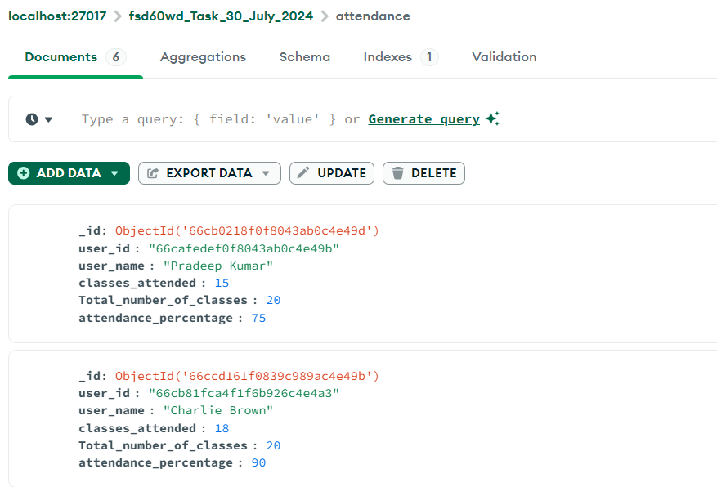

2) Sample copy of data present in codekata table

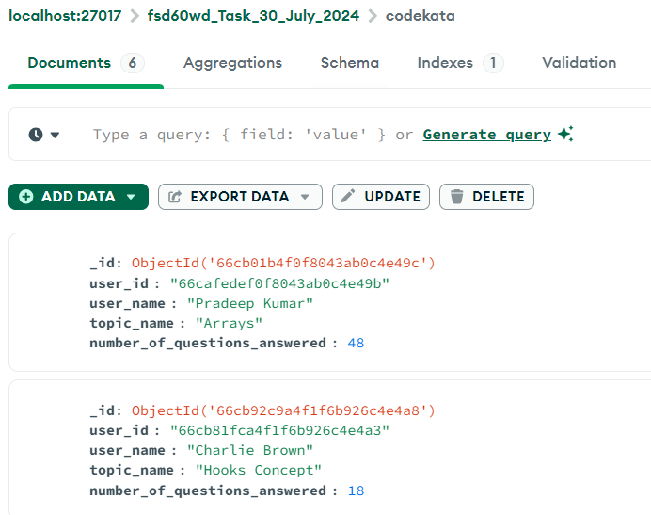

1. Sample copy of data present in company_drives table:

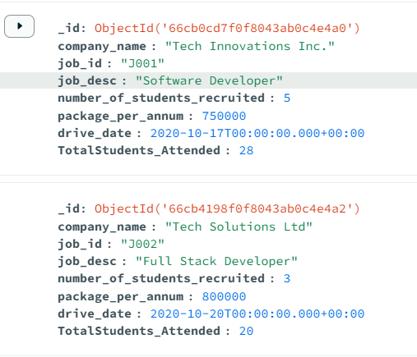

1. Sample copy of data present in mentors table:

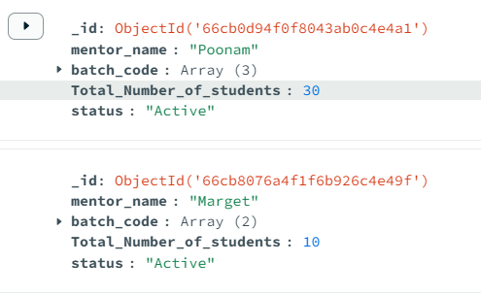

1. Sample copy of data present in tasks table:

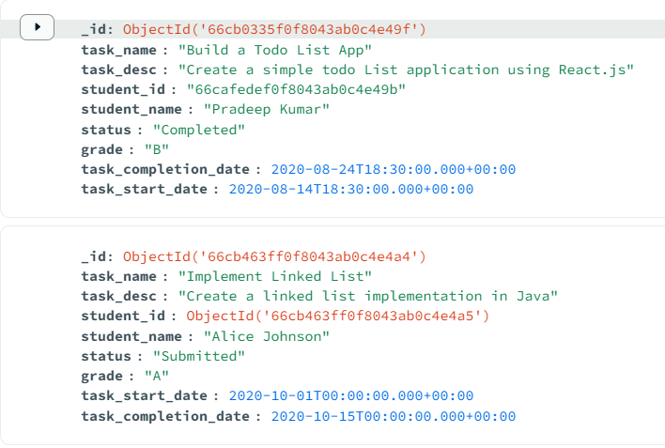

1. Sample copy of data present in topics table:

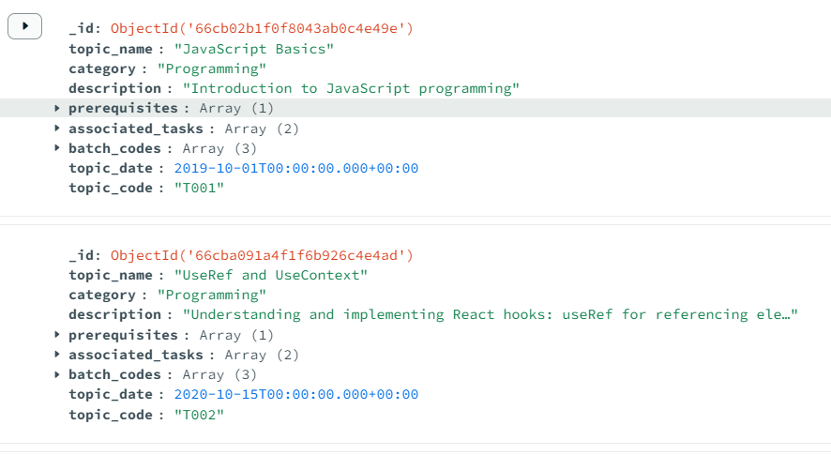

1. Sample copy of data present in users table

